﻿

﻿

Microservice Arch

Monday, 20 January 2025

2:57 PM

Optum-Azure04

P@lmeto@123

<https://SpritStarter.io> link to create the Micro service through online and download zip and unzip and load in Eclipse

In Sprint boot 2 jars will be there 1.orginal(only code) 2. .jar(Fat Jar with Bootup dependecies inlcuded)

<https://github.com/sbtalk71/optum-azure-ms>

Acutator : Topic:

management:

  endpoints:

    web:

      exposure:

        include: "\*"

  endpoint:

    health:

      show-details: always

Resilience4J and Circuit Breaker: Topic

Need to dependency Resiliene4j and aop in pom.xml

Promethus is used to visualize theactuator logs in spring microservices

Promethus- Collecting the data using the actuator

Grafana - Graphical visualise the logs

Micrometer - Used for metrics

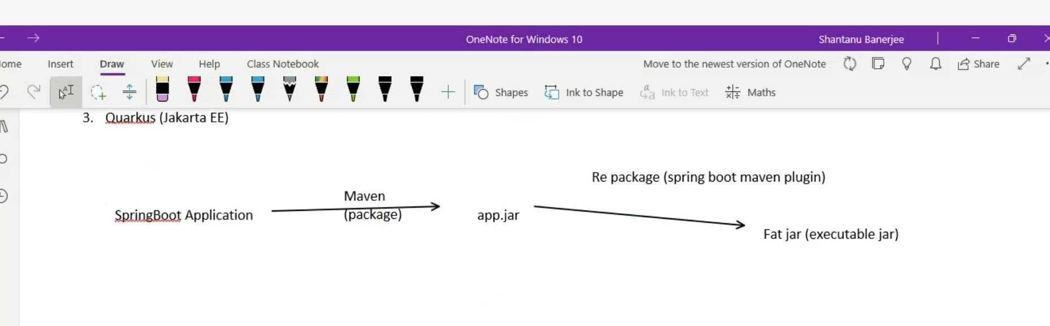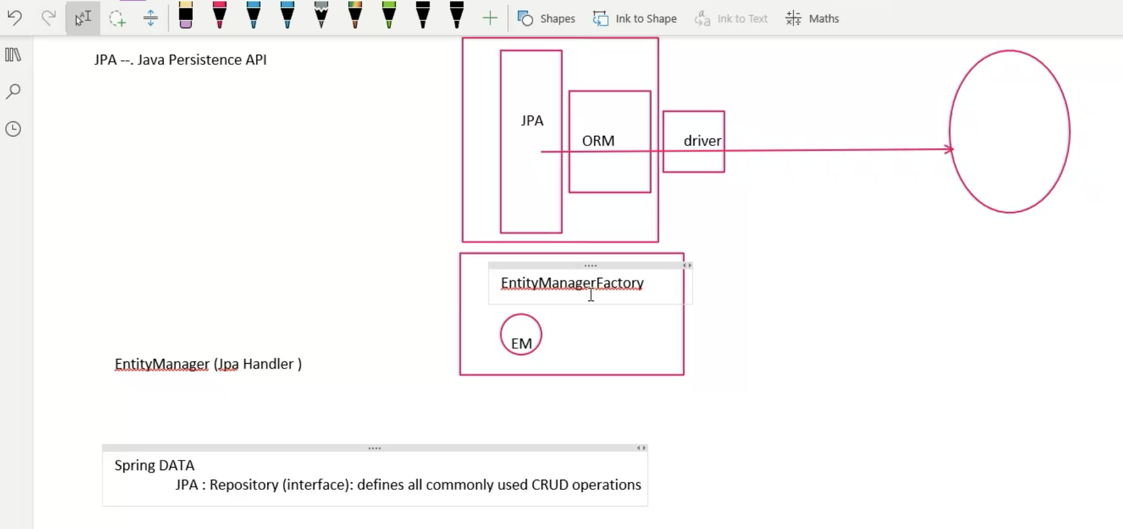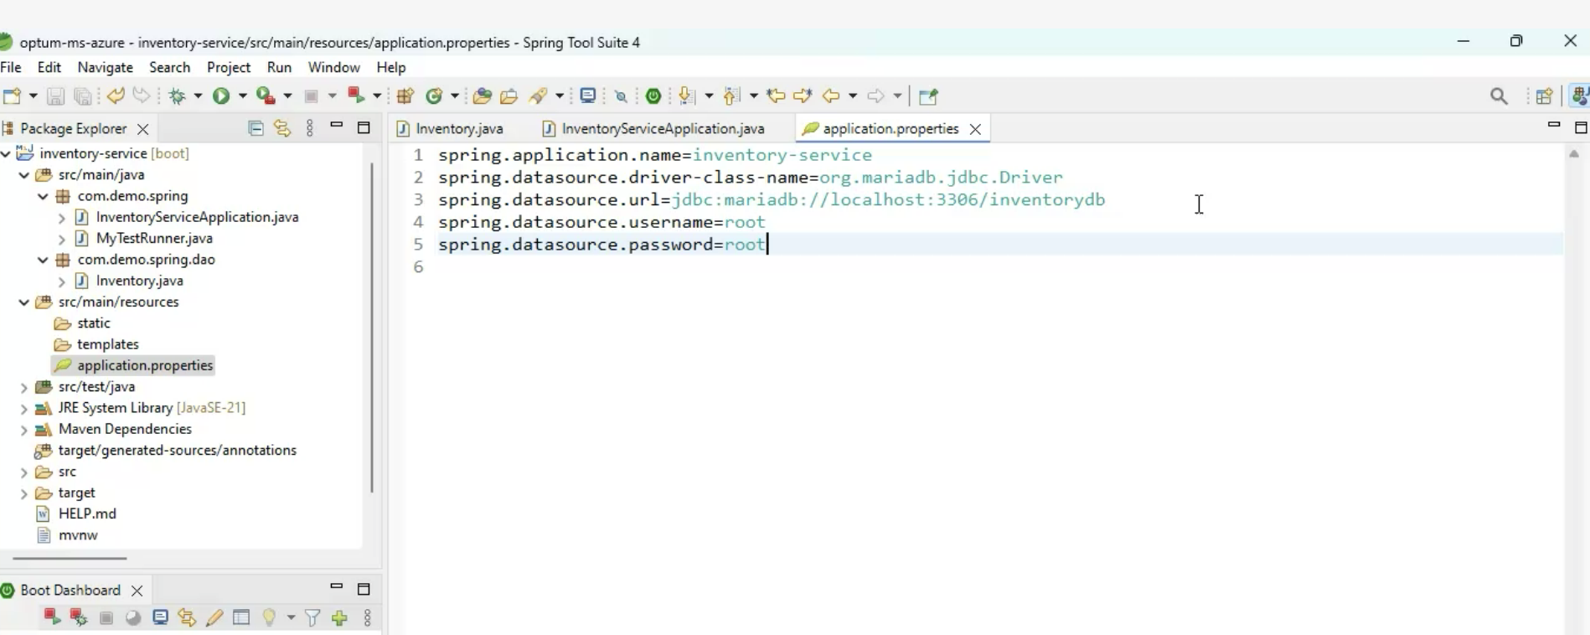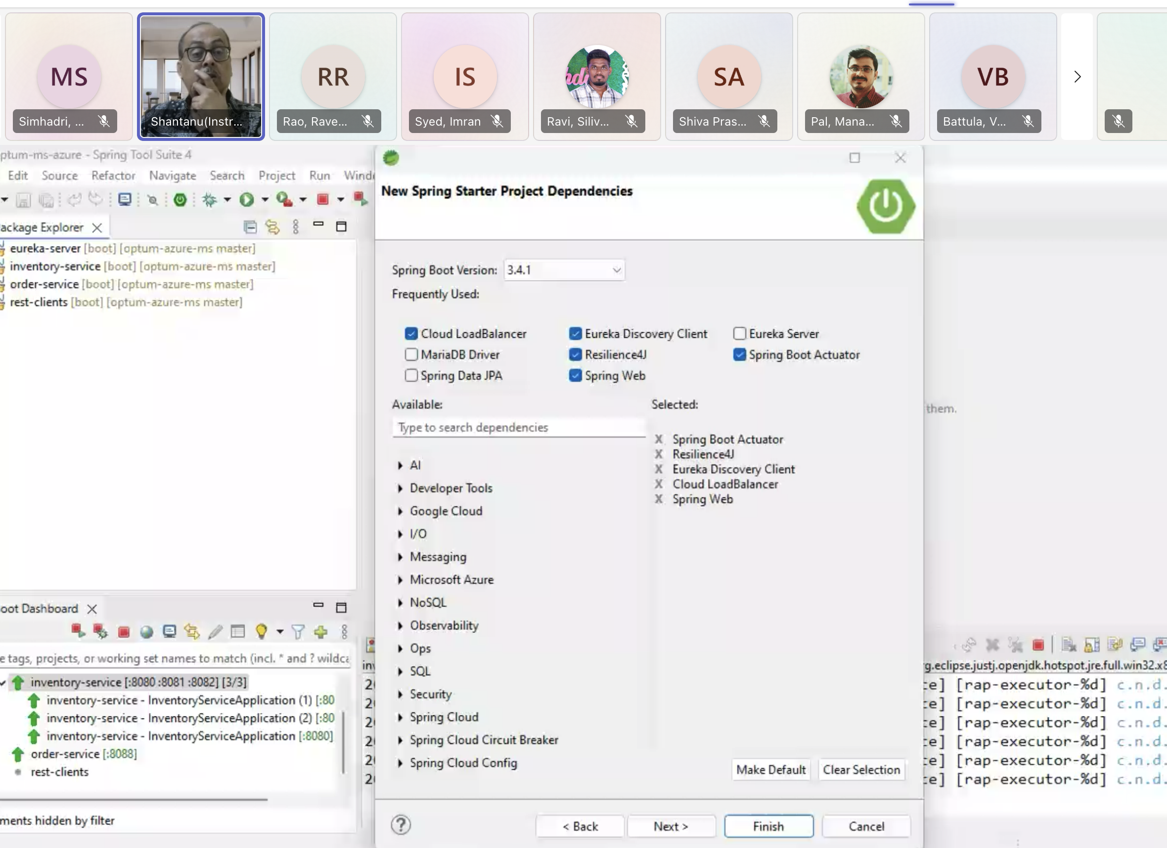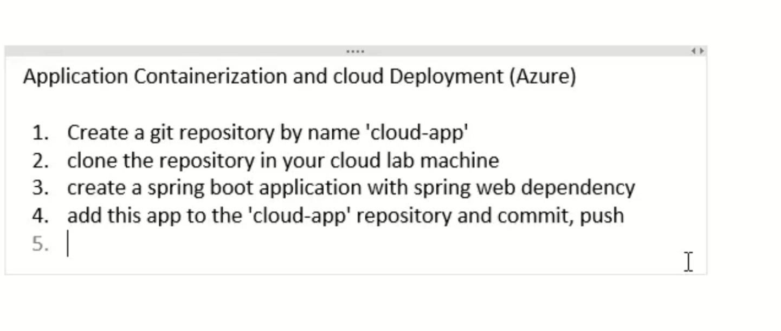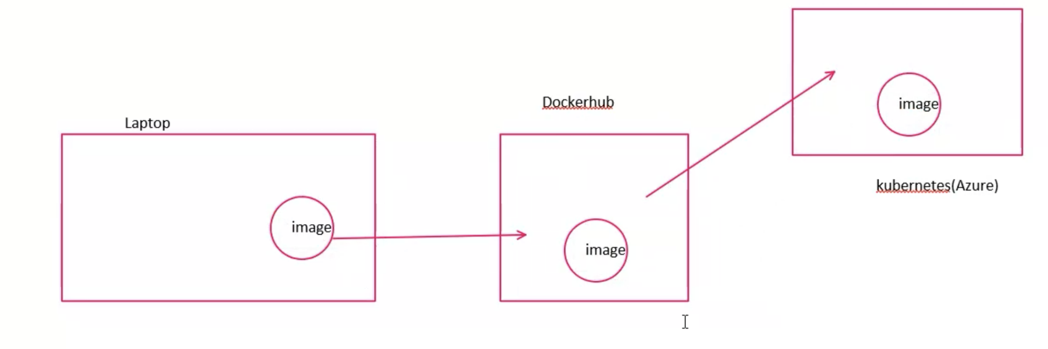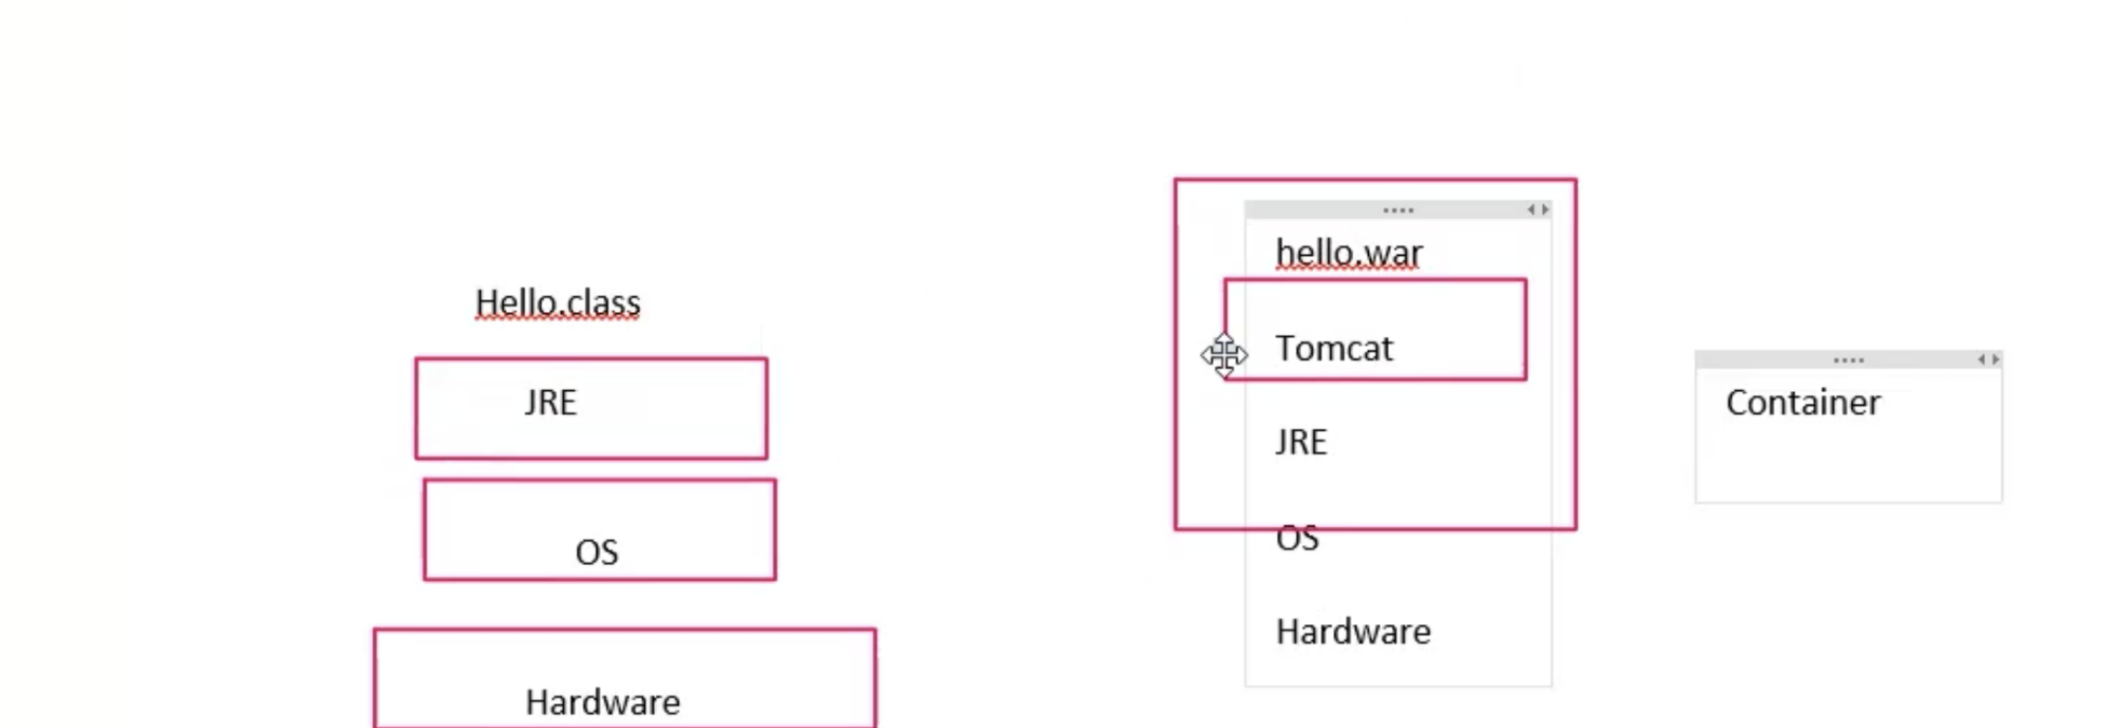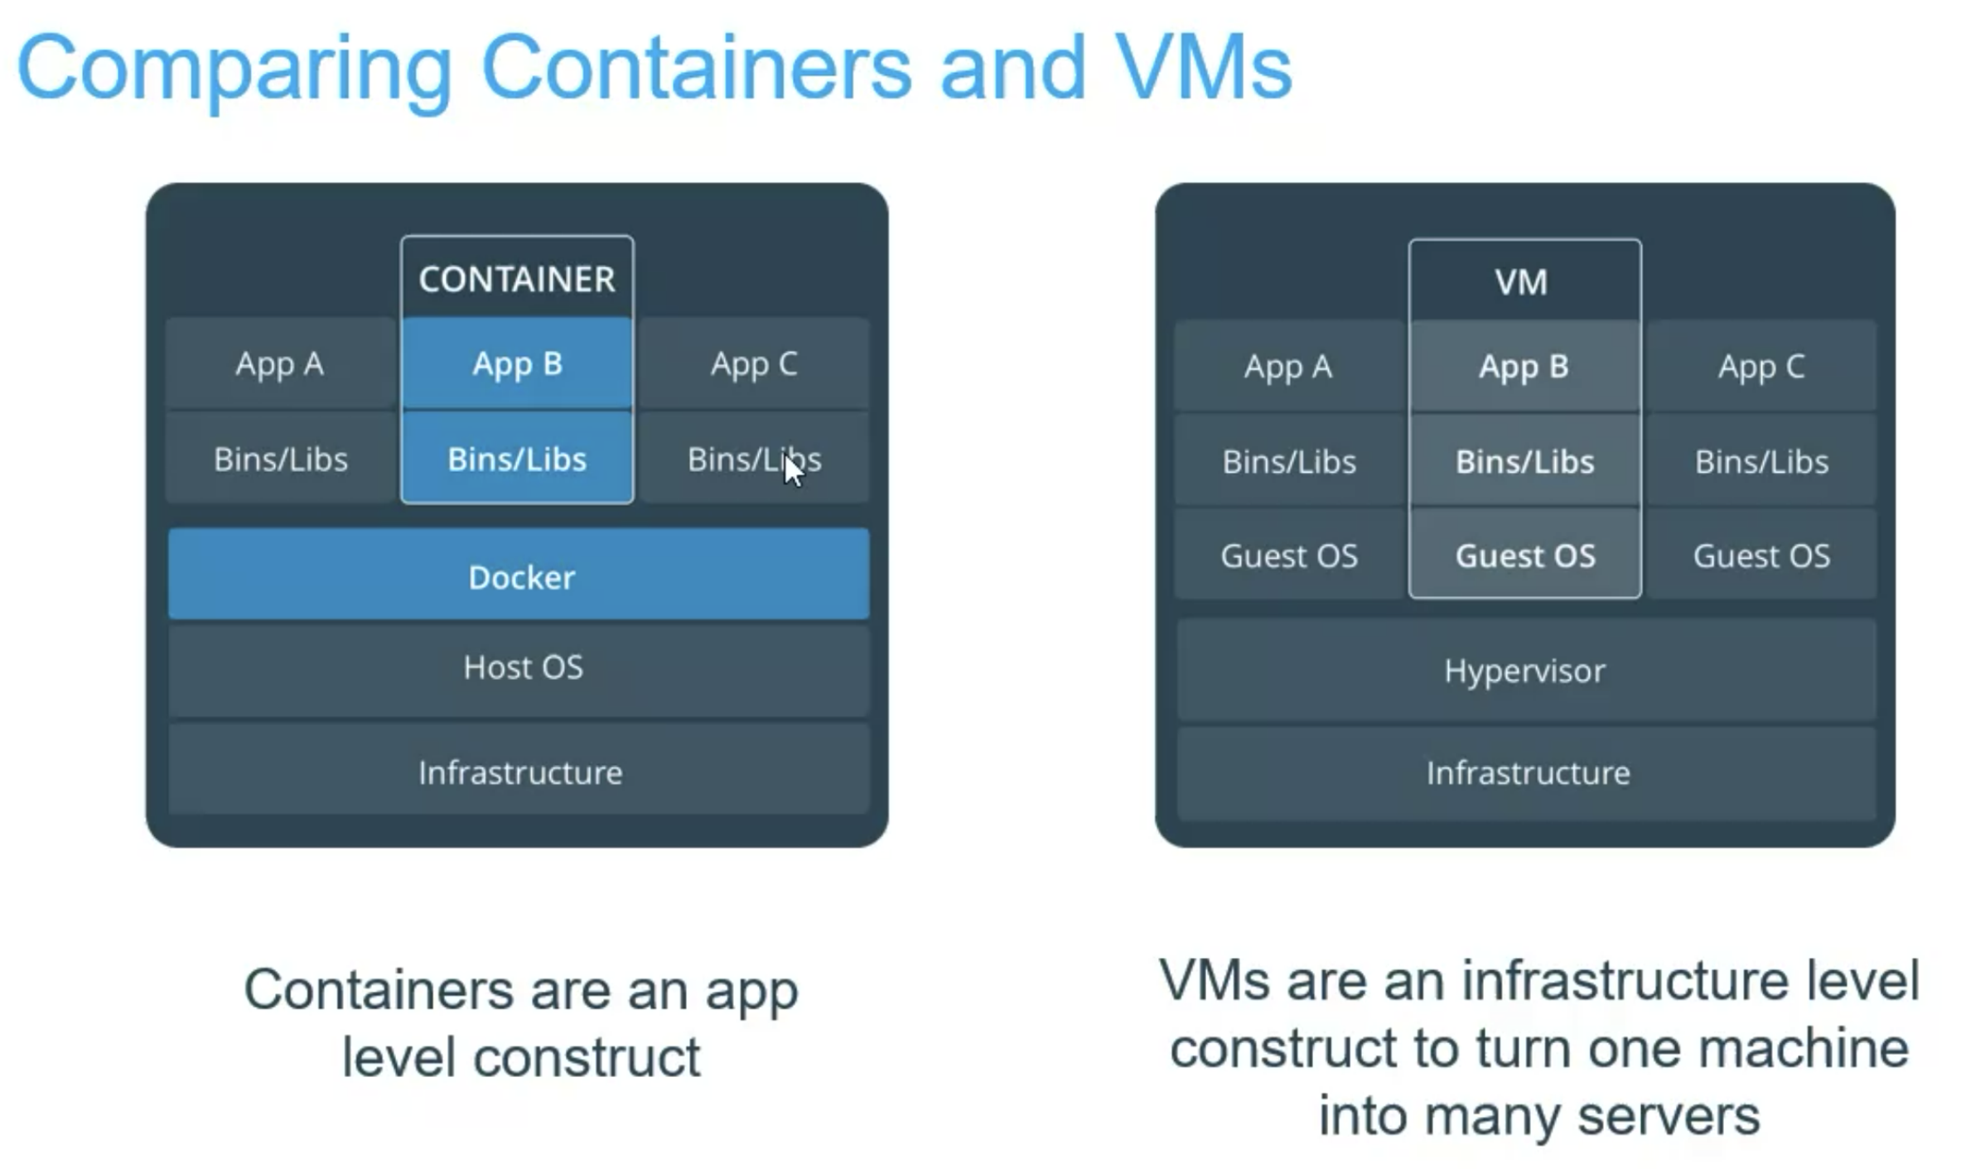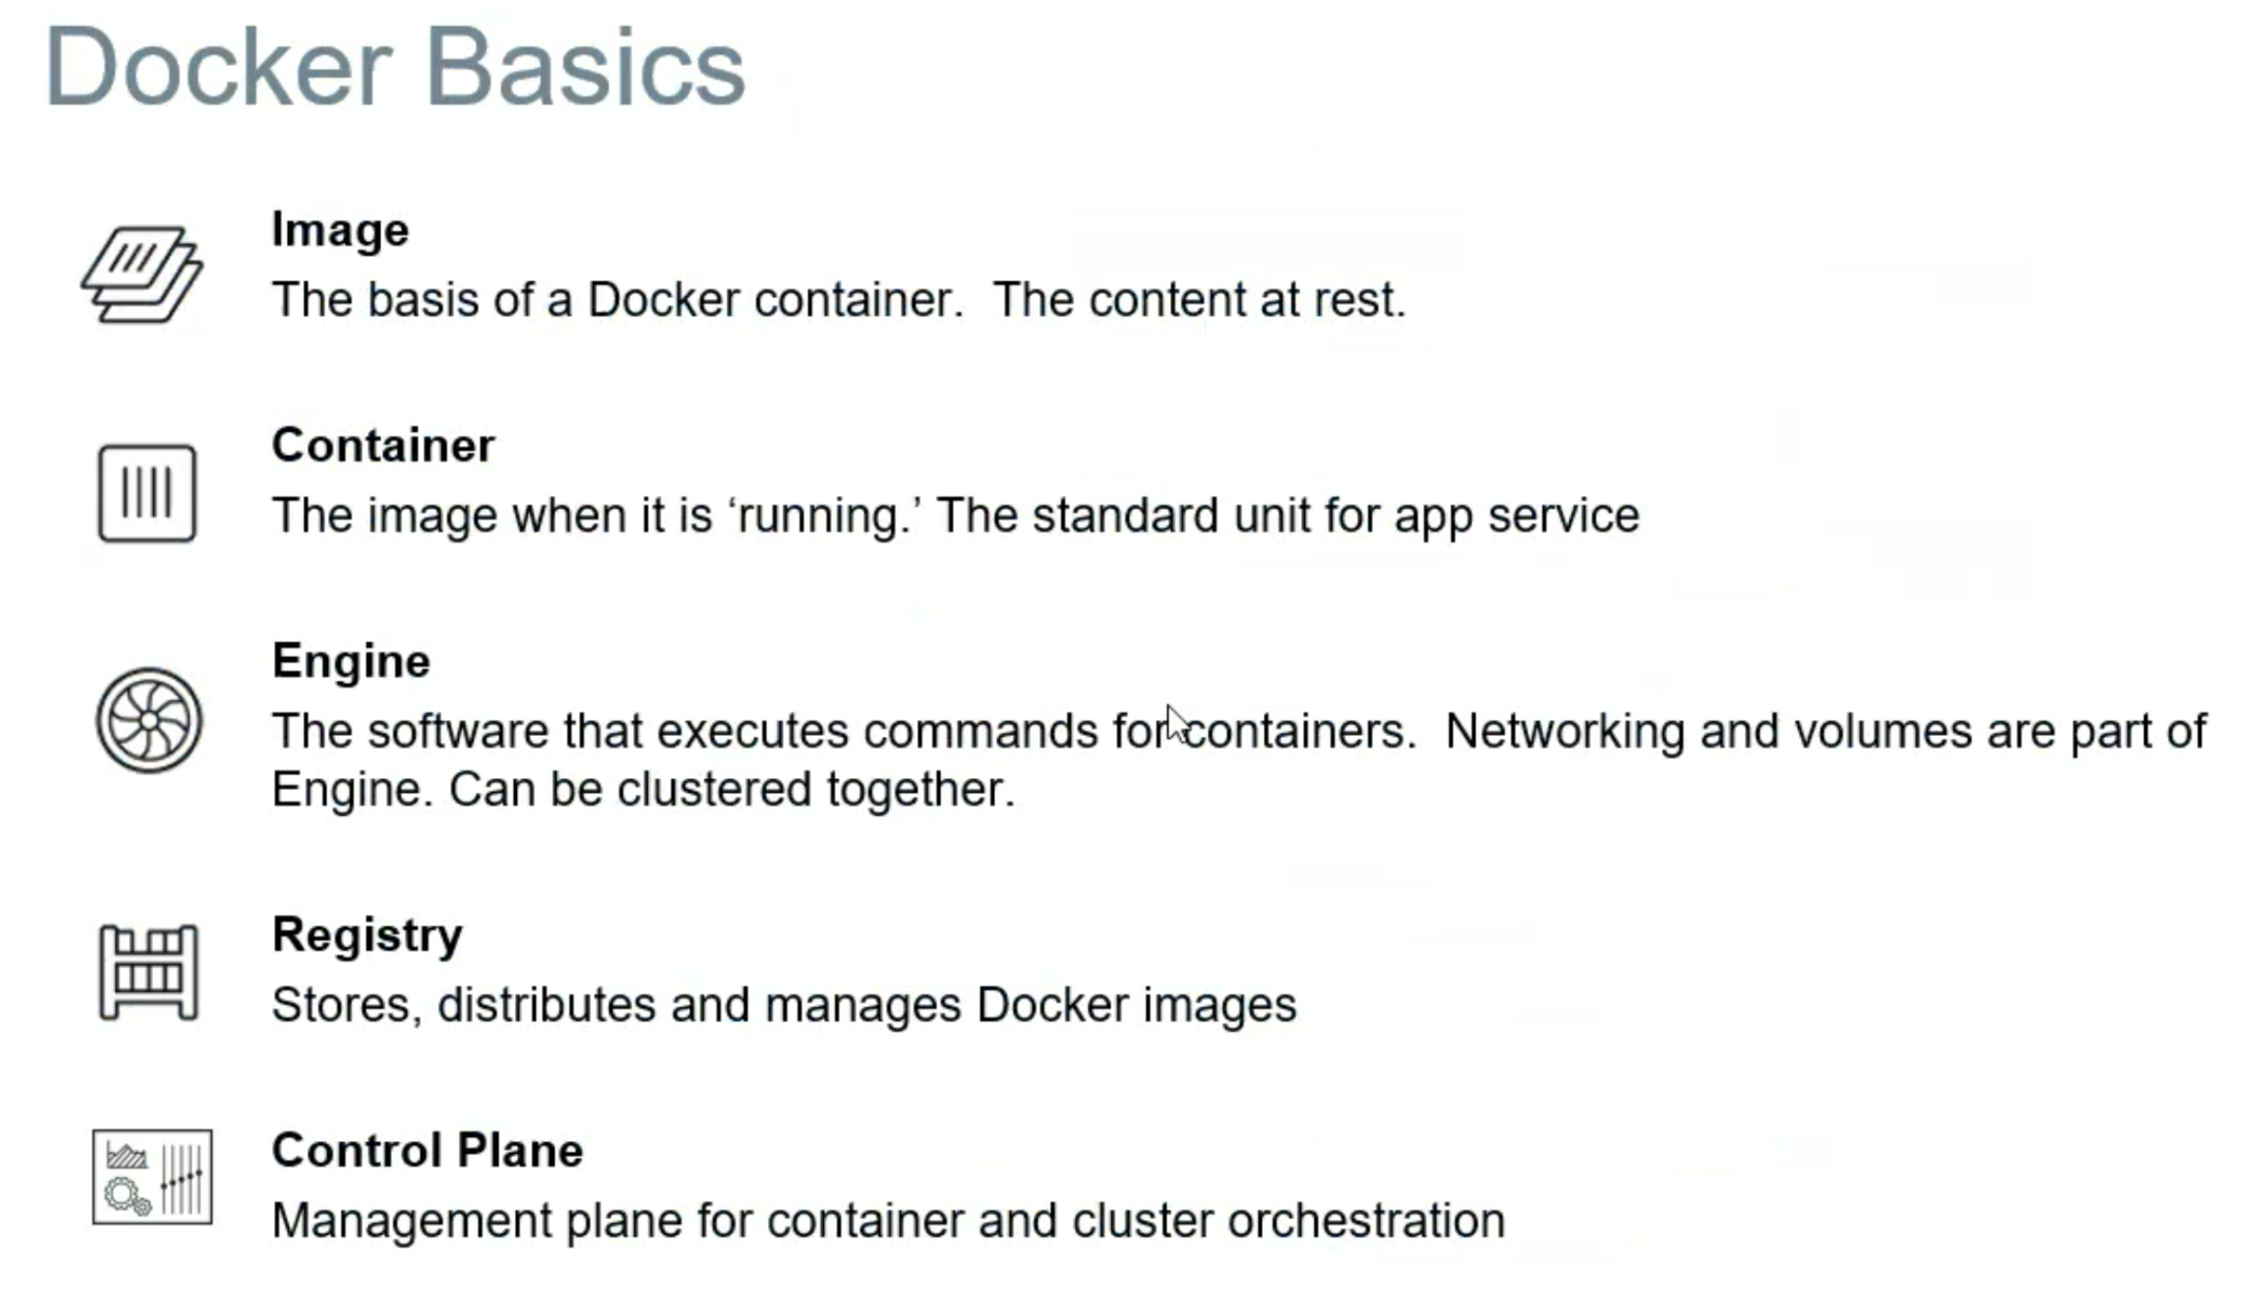

* docker image ls
* docker pull busybox latest
* docker run -it busybox sh - to run the container with interactive into that container
* docker stop - it will stop but not remove (not good command)
* Docker container ls -a - to display container dead or live
* Docker rm <containerid>
* Docker run --rm --name nginx -p 8000:80 -d nginx #portmapping/forwarding
* Docker logs <containerid>
* Docker exec -it <containerid> sh #to display logs

To Paractice : docker palyground site

Image is like class

Container - can be many deployed

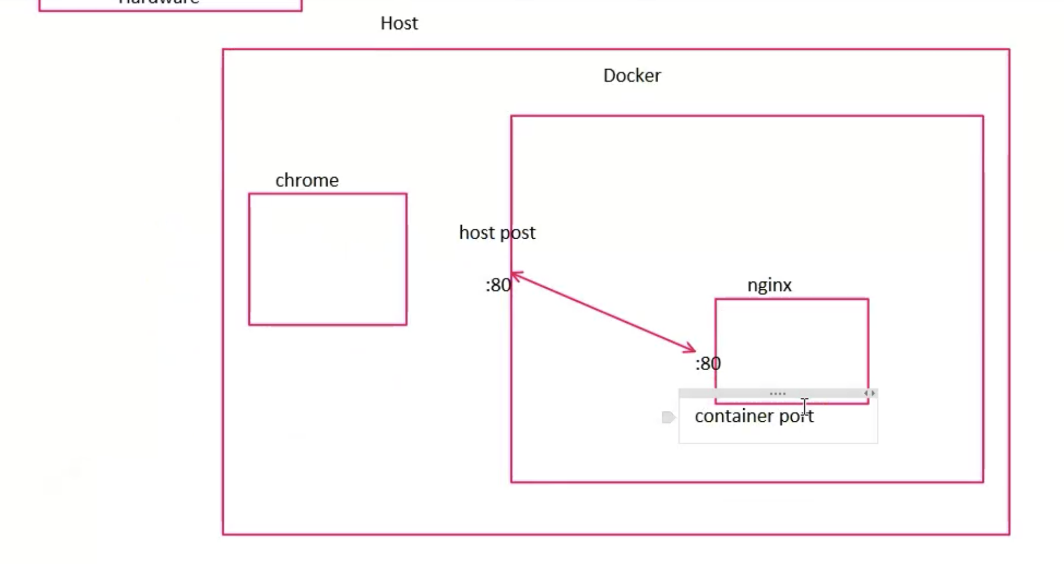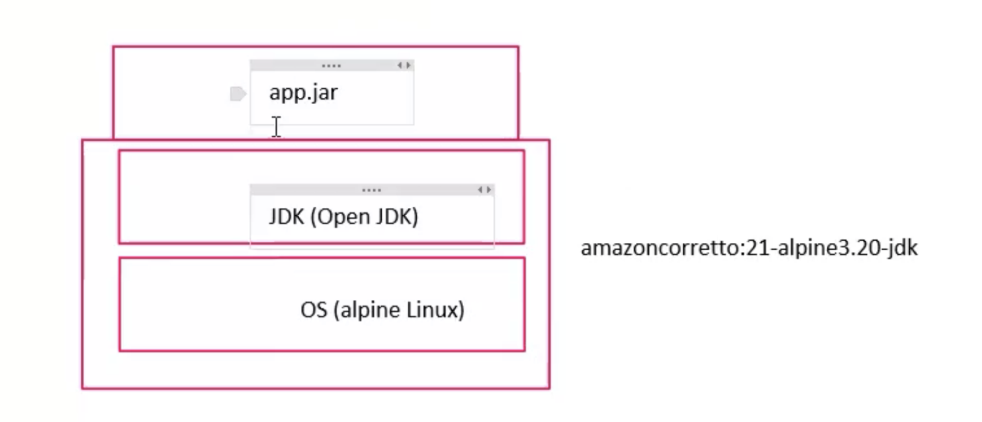

docker build -t suryamnaidu1985/greet-service:1.0 .

docker run --rm --name greeter -p 8090:8080 suryamnaidu1985/greet-service:1.0

Docker push suryamnaidu1985/greet-service:1.0

Kubernetes:

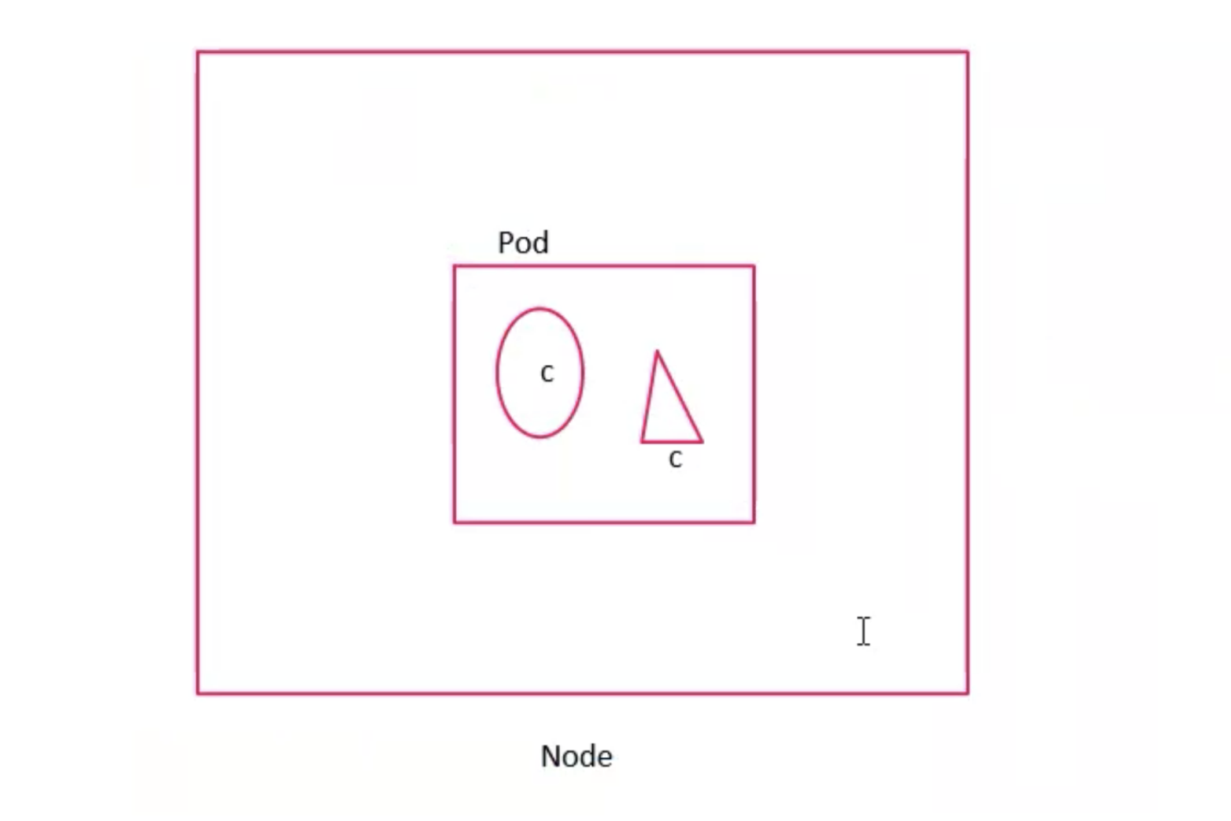

Node means is machine

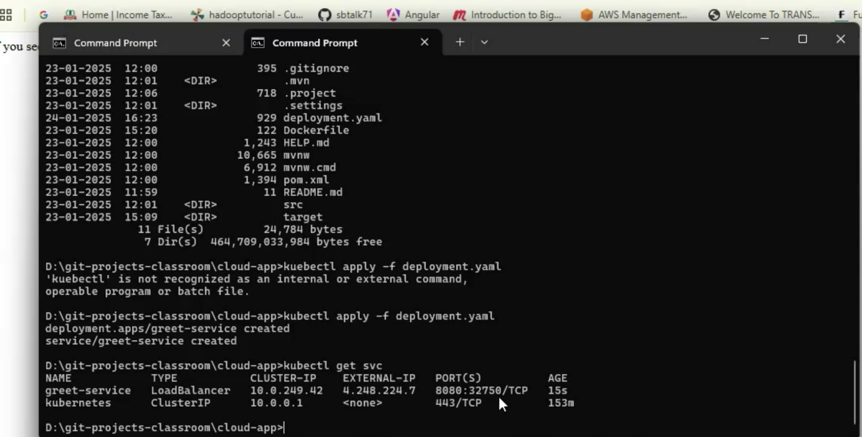

Created with OneNote.